Hot Mix Asphalt: Footnote (a)

A NIST traceable digital manometer (shown below) has been purchased and installed with the vacuum system.

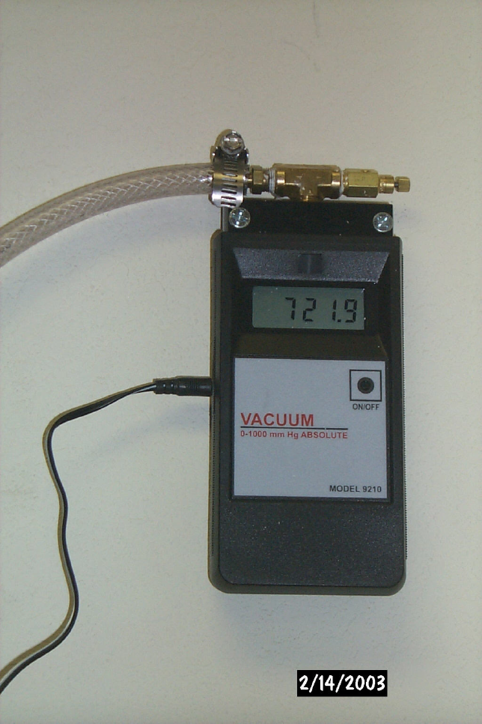

A vacuum gauge has been repositioned using a “T” connector at the vacuum pump (shown below).

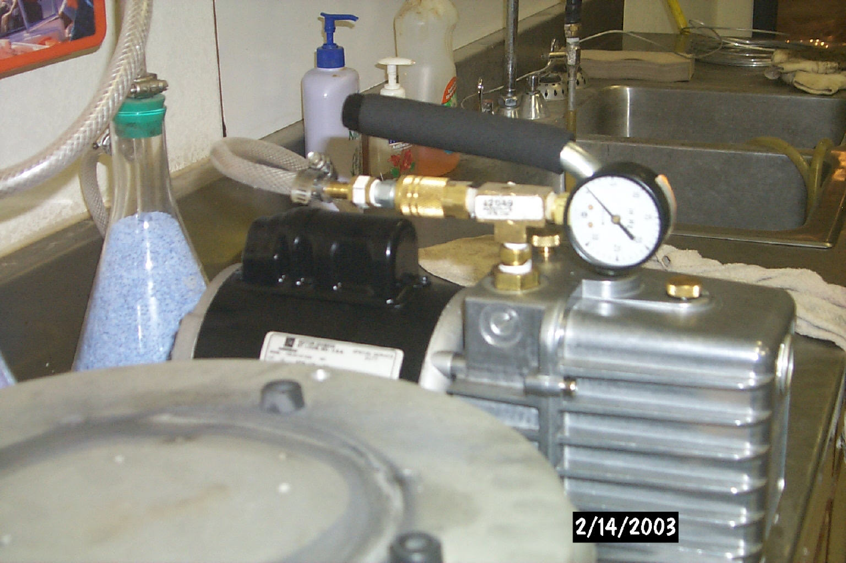

The overall setup for method T209 is shown in the following photo.

